Portfolio Optimization using Simplex Method
Objective: To construct an optimal investment portfolio by selecting weights for 30 NSE-listed stocks such that portfolio risk is minimized while satisfying specific constraints on return, budget, liquidity, and sector diversification.
Analysis Tool used:
Excel solver

Step 1: Data Collection and Preparation We began by identifying a well-diversified set of 30 stocks from the NSE across multiple sectors including Banking, IT, Energy, Industrial, FMCG, and Healthcare. Historical stock price data for each of these was collected for a 3-year period (April 2022 to April 2025). Monthly closing prices were used to calculate monthly returns for each stock.

Step 2: Calculating Portfolio Risk (Objective Function) The primary goal was to minimize the portfolio risk, which we defined as the variance (or total squared deviation) of portfolio returns. We calculated the deviation of each stock's return from its mean across 36 months. Then, for each month, we computed the weighted deviation of the portfolio (based on assigned weights). Finally, the sum of squared deviations across all months served as the objective function.
Let:
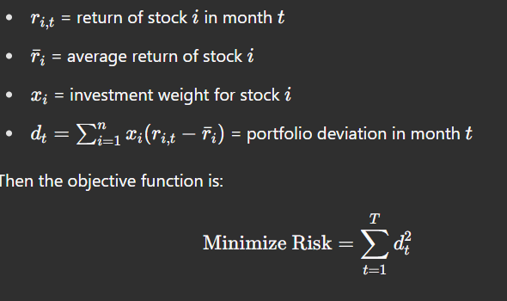
Excel Formula Used:
- To calculate deviation: =Actual Return - Average Return
- To calculate weighted monthly deviation: =SUMPRODUCT(Deviation Range, Weight Range)
- To calculate total risk (objective): =SUMSPRODUCT(Monthly Deviation Results,Monthly Deviation Results)

Step 3: Defining Decision Variables The decision variables in this model were the investment weights assigned to each of the 30 stocks. These were constrained to be non-negative and collectively sum to 1, representing a fully invested portfolio with no short selling.

Step 4: Setting Constraints We imposed the following constraints:
- Budget Constraint:
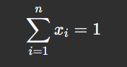
Excel Formula Used: =SUM(Weights)
- Return Constraint: Let be the average return of stock i. Then:
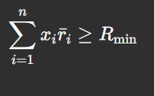
Excel Formula Used: =SUMPRODUCT(Average Return Range, Weight Range)
How Was Calculated: To estimate a reasonable return threshold, we used the NIFTY 50 index as the benchmark. We observed that:
- NIFTY 50 in April 2022: ~17,600
- NIFTY 50 in April 2025: ~22,500
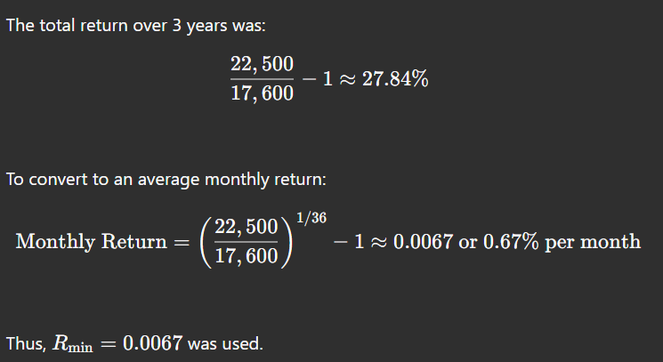

- Liquidity Constraint: Let be the average trading volume of stock i. Then:
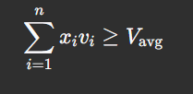
Excel Formula Used: =SUMPRODUCT(Volume Range, Weight Range)
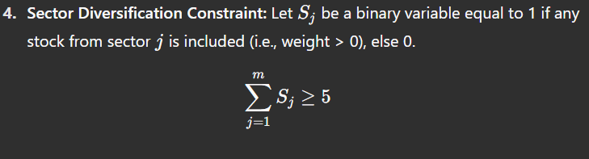Excel Helper Logic:
- For each sector: =IF(SUMIF(Sector Range, "SectorName", Weight Range) > 0, 1, 0)
- Total sectors: =SUM(Helper Cells)

Step 5: Solver Configuration Using Excel Solver:
- Objective Cell: Set to minimize the total portfolio risk (sum of squared deviations).
- Changing Variable Cells: Investment weights for the 30 stocks.
- Constraints: Applied as described above, including non-negativity.
- Solving Method: Simplex LP was selected as the optimization model was linear or piecewise linear.

Step 6: Column-Wise Formula Summary from Excel Sheet
Column/Range | What It Represents | Formula Used
M1 to M36 | Monthly returns for each stock over 36 months | Input manually or using: =(Current Month Close / Previous Month Close) - 1
Avg Return | Average return per stock | =AVERAGE(M1:M36)
Dev M1 to Dev M36 | Deviation from average return per stock | =M1 - [Avg Return]
Investment Weight (x) | Decision variable for each stock | Initially set to 0 or =1/30, then optimized using Solver
Weighted Deviation | Monthly weighted portfolio deviation | =SUMPRODUCT(Dev M1:M36, Weight Range)
Average Volume | 3-year average trading volume for each stock | =AVERAGE(Volume Data) or provided manually
Sector Helper Cells | Binary indicators for each sector's inclusion | =IF(SUMIF(Sector Range, "SectorName", Weight Range) > 0, 1, 0)
Total Sectors Represented | Total number of sectors included | =SUM(Sector Helper Cells)
Portfolio Return | Expected return of the portfolio | =SUMPRODUCT(Average Return Range, Weight Range)
Portfolio Liquidity | Weighted average trading volume | =SUMPRODUCT(Average Volume Range, Weight Range)
Total Portfolio Risk | Final objective to minimize | =SUMSQ(Monthly Weighted Deviations)

Conclusion:
By applying these systematic steps, we formulated a robust portfolio optimization model in Excel. The resulting portfolio meets financial performance standards while balancing risk, liquidity, and diversification. This exercise demonstrates how quantitative techniques can be effectively applied using spreadsheet tools to make informed investment decisions.
RESULT:
